The North Staffordshire Woodland Project

In April 2018, The North Staffordshire Woodland Project was initiated; a project founded by our Chair David Nixon. The aim of the study is to determine the woodland species assemblage, distribution and behavioral patterns of bats that utilise North Staffordshire’s woodlands. It is part of a wider study to determine the distribution of bat species in this area of the county. The project involves undertaking bat detector surveys coupled with advanced trapping techniques to identify species. The project’s primary focus is on Myotis bat species that predominantly inhabit broad-leaved woodland as part of their ecology and which are difficult or impossible to distinguish with bat detectors alone.

During the active season, trapping is carried out at multiple sites. The woodlands that characterise North Staffordshire are unique within the county. The area is a transitional landscape from lowland to upland with parts reaching over 1000ft above sea level. It overlies ridges of millstone grit that form the southern-most tip of the Pennines, as well as sandstones and mudstones. A predominately farmed landscape of undulating permanent pasture occupying hills and plateaus, it is dissected by rivers and steep ravines. These often gorge-like wooded stream valleys (known as cloughs) enclose other habitats, including traditional hay meadow, wood pasture, wet flushes and upland heathland, giving way to extensive tracts of moorland to the north. There is a diverse range of running and still-water habitats bordered by woodland that provide ecological connectivity.

A range of woodland types is present from oak and birch woodland typical of western parts of the British Isles; ash and wych elm woodland on base-rich soils; and riparian and carr woodland of alder and willow. Conifer plantations are also present particularly to the east. Collectively, the woodlands of the Churnet Valley and Coombes Valley Sites of Special Scientific Interest (SSSI) are the finest example of woodland in the area and the largest remaining concentration of high quality semi-natural ancient woodland in Staffordshire. These SSSIs are rich in birds and invertebrates. Bird species including pied flycatcher, common redstart, wood warbler and tree pipit are annual breeders throughout the Churnet Valley and surrounding areas, all of which are species associated with western and upland woodland settings. This rich habitat with characteristics of western oak woodland supports a wealth of invertebrates, with over 30 species of beetle.

The extent of the study area includes Natural England’s Potteries and Churnet Valley National Character Area (64). Staffordshire Bat Group has a long history of recording bats in North Staffordshire, particularly in the Churnet and Coombes Valleys. Over time, the surveys have shown that the Churnet Valley woodlands in particular, appear to be a strong-hold for Brandt’s bats.

In conjunction with Staffordshire Bat Group, the Vincent Wildlife Trust funded a bat box scheme in the Churnet Valley based upon the excellence of the woodland habitat. In 2004, one hundred Schwegler 1FF boxes were installed in woodland at Consall Nature Park, with a view to ascertain if the geographical distribution of barbastelle bats extended to North Staffordshire’s unique wooded areas (Poulton, 2006). While barbastelle bats were never recorded, male whiskered bats were detected using the boxes within six months and, notably, the following year (2006) a Brandt’s maternity colony began using the boxes. Since 2015, Natterer's have been recorded using the boxes with numbers increasing each year and the Brandt’s maternity colony appears to have moved elsewhere.

An advanced trapping study ran for a number of years at Froghall Lime Kilns in the Churnet Valley, which focused on recording swarming activity of bats at this structure. A number of species were found including Natterer's, Daubenton's, Brandt's, whiskered and brown long-eared (the project holders, Phil Burkenshaw and Tony Taylor have both sadly passed away).

Surveys have also been undertaken at Oakamoor railway tunnel (disused) that is used by roosting Brandt's, whiskered and Natterer's (as well as brown long-eared and, unusually given the nature of the structure, common pipistrelle). Roosts and bat boxes have been monitored at Coombes Valley and Consall Forge and numerous bat detector surveys have been carried out.

During 2017, in preparation for The North Staffordshire Woodland Project, walking transects were carried out once a week during the active season (April to late September). It is hoped that project will provide valuable information on the presence and distribution of Myotis bats in this part of the county. The records will feed into the databases held by Staffordshire Bat Group and Staffordshire Ecological Record helping to provide a better understanding of the prevalence of these species in the area and in turn supporting their conservation. This is particularly important for Brandt’s. Brandt’s bat is not considered common in the UK and is generally confined to the west and north of England and is rare or absent elsewhere; it may have declined significantly in recent years (Battersby, 2005). In Staffordshire it is very rare although likely under-recorded (Crawley, et al., 2007).

The project is focused on Brandt’s, whiskered and Natterer’s bats. Given that this project is the first of its kind in North Staffordshire since the Alcathoe bat Myotis alcathoe was described in 2010, small Myotis species are fur-clipped to confirm the identity of these cryptic species where necessary. Any records of Alcathoe would be of great note as there are no known records of this species in the county.

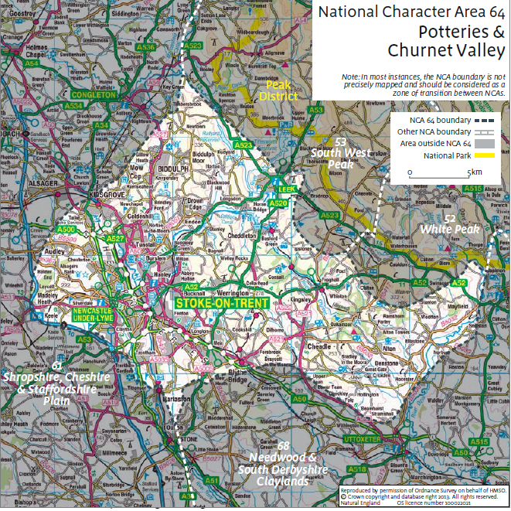
Figure 1: Shows National Character Area 64 (Potteries & Churnet valley)
Map produced by Natural England

The project provides valuable insight into the distribution and assemblages of bats using North Staffordshire’s woodlands, it highlights the importance of the woodlands for bats and contributes to the conservation and understanding of bats in the county.

During the summer months, harp traps and mist nests are used in association with acoustic lures to catch bats at woodland sites in North Staffordshire. Locations vary and include woodlands in private ownership as well as those owned by the RSPB, Staffordshire Wildlife Trust, Staffordshire Moorlands District Council and Stoke-on-Trent City Council. The number of mist nets erected depended on the number of competent field workers present.

All captured bats ware carefully removed from the nets and harp traps by an experienced bat worker, then hung up in bat bags and processed immediately. The bats are then handled and identified under supervision of the licensee or an Additional Authorised Individual, then immediately released. Information collected, includes: species, sex, age, breeding condition, weight and forearm length. Although the primarily focus was/is Myotis species, all bat species caught were processed and data will be fed into Staffordshire Bat Group’s record data base; it was also submitted to the local record centre, Staffordshire Ecological Record.

Small Myotis species including whiskered and Brandt’s are fur clipped for DNA analysis as some specimens can be difficult to identify in the hand. In addition, Natterer’s, whiskered and Brandt’s forearms (one forearm) are marked using chalk pen suitable for use on bats. This method was used to establish if these species have previously been caught during the evening.

The first two years were a huge success – we managed to capture copious amounts of data, had great fun and look forward to the fourth coming season of 2020. Furthermore, it would not have been possible to run the project without the help of our dedicated group members, who spent long nights helping to erect nets, process bats and capture important data. Thanks also to Helen Ball who has extensive knowledge of the woodlands of North Staffordshire and has contributed many years’ worth of survey and monitoring data to Staffordshire Bat Group and Staffordshire Ecological Record. Her local knowledge of the area and experience with surveying for bats is vital in helping to support the project.

